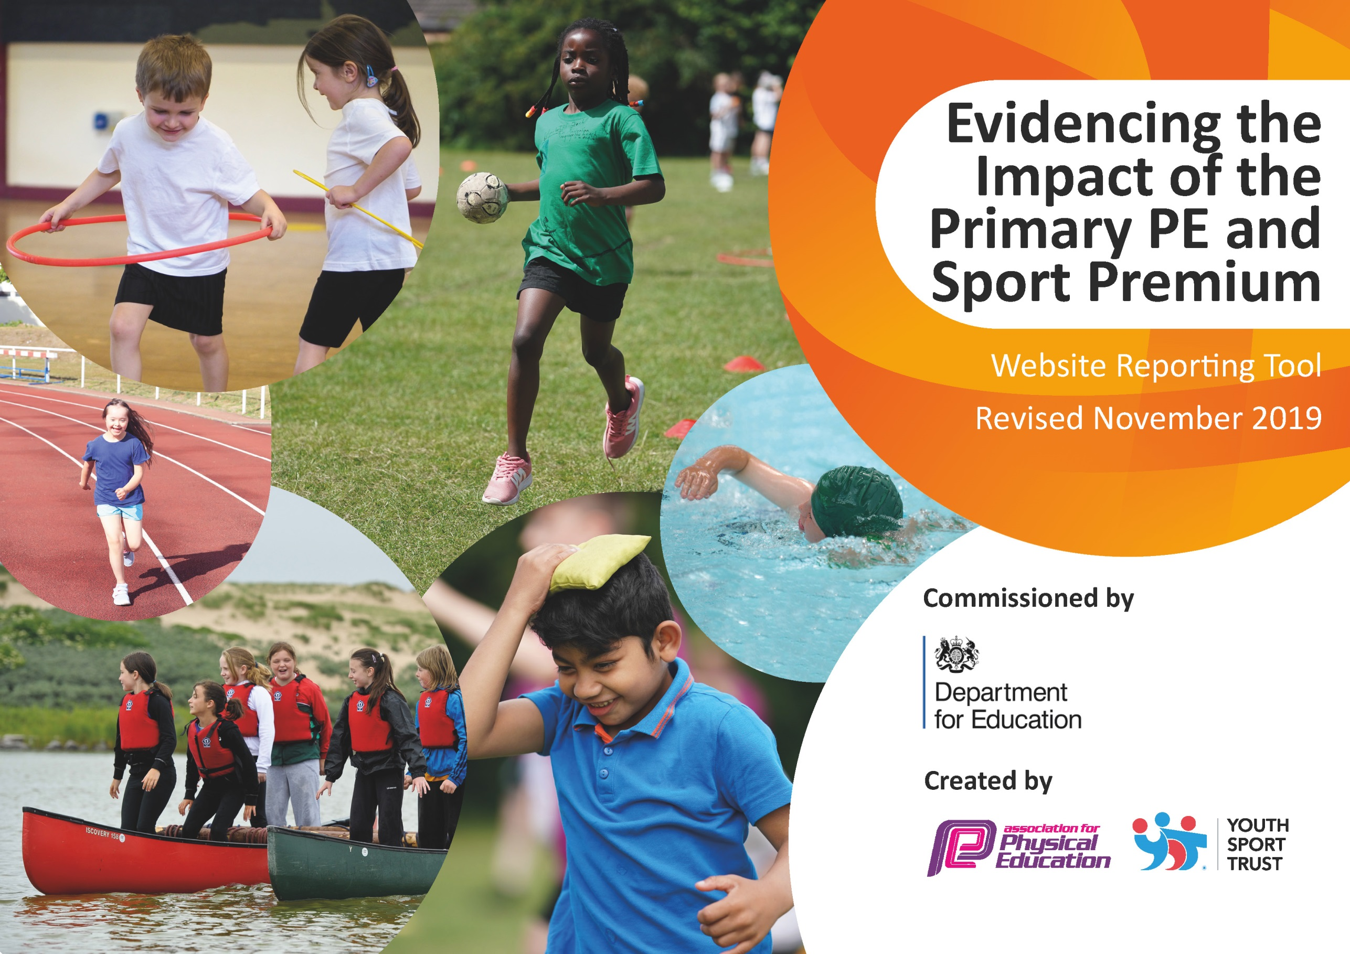
July 2020
COVID19
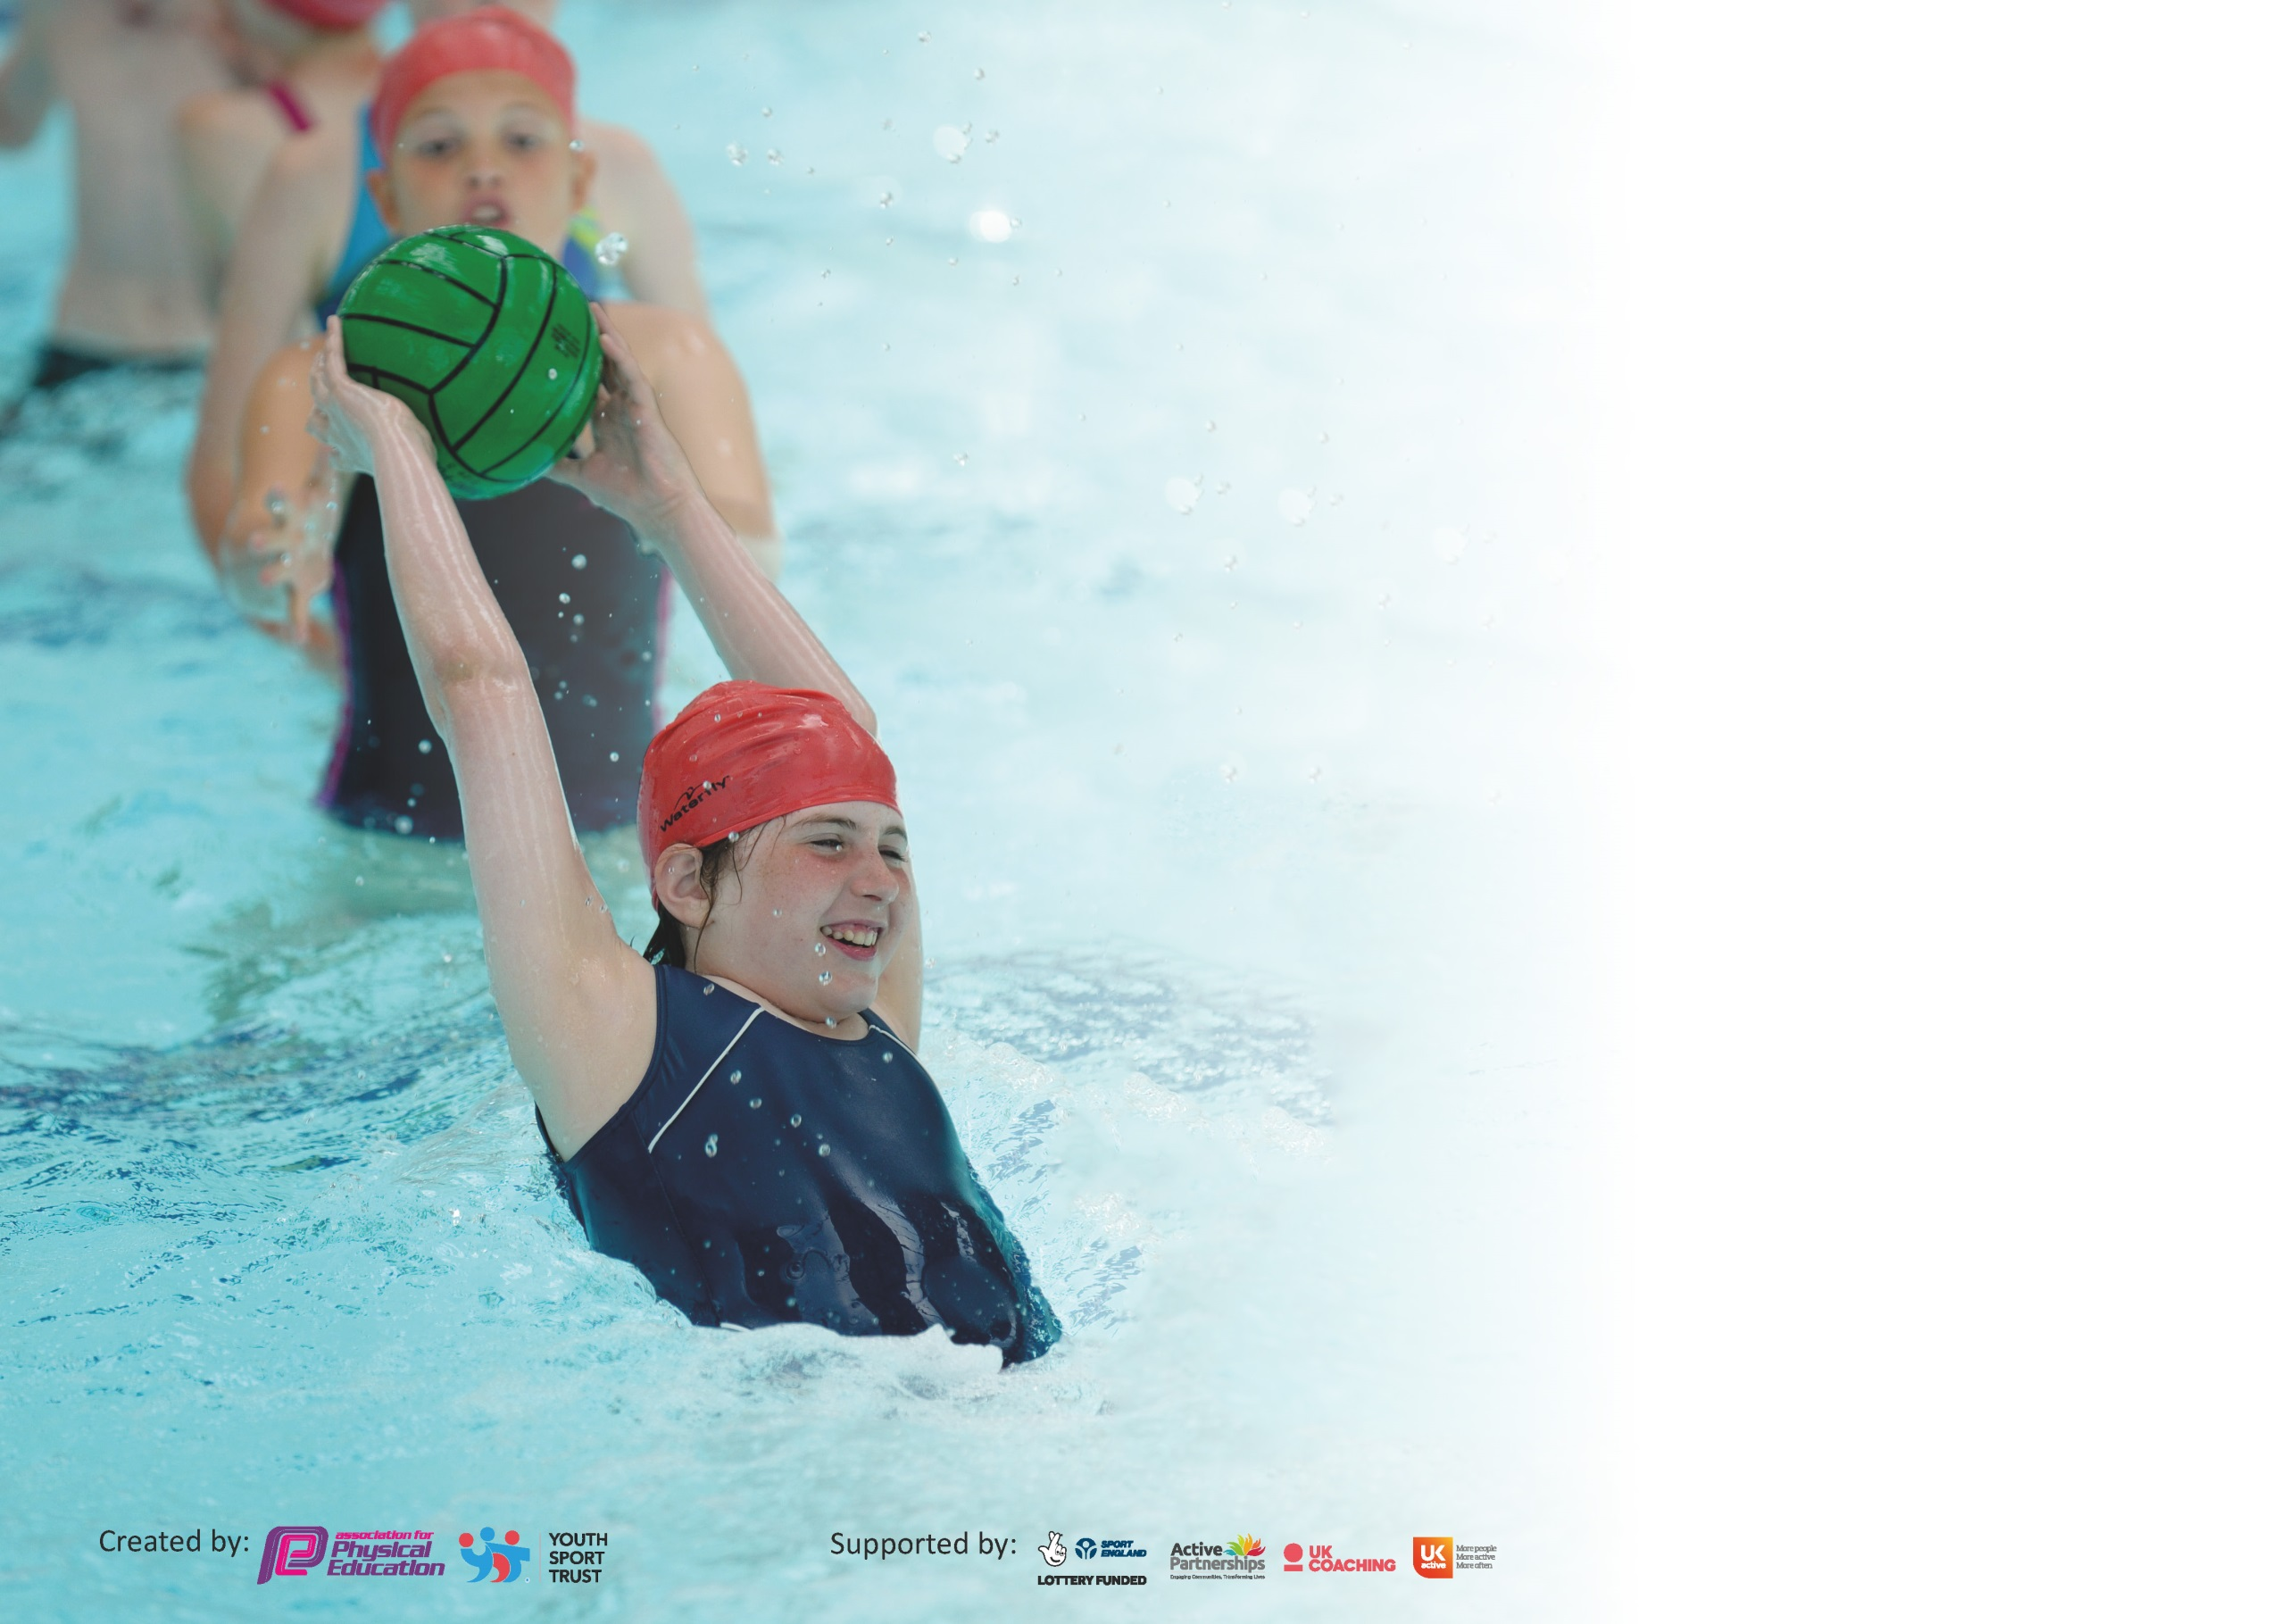

It is important that your grant is used effectively and based on school need. The Education Inspection Framework (Ofsted 2019 p64) makes clear there will be a focus on ‘whether leaders and those responsible for governors all understand their respective roles and perform these in a way that enhances the effectiveness of the school’.

Under the Quality of Education criteria (p41) inspectors consider the extent to which schools can articulate their curriculum (INTENT), construct their curriculum (IMPLEMENTATION) and demonstrate the outcomes which result (IMPACT).

To assist schools with common transferable language this template has been developed to utilise the same three headings which should make your plans easily transferable between working documents.

Schools must use the funding to make additional and sustainable improvements to the quality of Physical Education, School Sport and Physical Activity (PESSPA) they offer. This means that you should
use the Primary PE and Sport Premium to:

- Develop or add to the PESSPA activities that your school already offer
- Build capacity and capability within the school to ensure that improvements made now will benefit pupils joining the school in future years

Please visit gov.uk for the revised DfE guidance including the 5 key indicators across which schools should demonstrate an improvement. This document will help you to review your provision and to report your spend. DfE encourages schools to use this template as an effective way of meeting the reporting requirements of the Primary PE and Sport Premium.

We recommend you start by reflecting on the impact of current provision and reviewing the previous spend.

Schools are required to publish details of how they spend this funding as well as on the impact it has on pupils’ PE and sport participation and attainment by the end of the summer term or by 31st July 2020 at the latest.

We recommend regularly updating the table and publishing it on your website throughout the year. This evidences your ongoing self-evaluation of how you are using the funding to secure maximum, sustainable impact. Final copy must be posted on your website by the end of the academic year and no later than the 31st July 2020. To see an example of how to complete the table please click HERE.

Support for review and reflection - considering the 5 key indicators from DfE, what development needs are a priority for your setting and your pupils now and why? Use the space below to reflect on previous spend and key achievements and areas for development.

Key achievements to date until July 2019: | Areas for further improvement and baseline evidence of need:
100% of children achieving 2hrs+ in PE  100% of children participating in physical activity at school which exceeds the recommended 30 mins  Increased level of participation in inter-school competition  Increased staff confidence and knowledge in the delivery of PE  School Games Gold Award  YST Silver Award (2018-2020)  School Games Virtual Award for at home and in school physical activity during national School closures due to Covid-19  School Sport achievements:  Y5/6 Cross Country Cluster Champions – Boys team (1st, 2nd, 3rd and 5th place)  Y5/6 Cross Country Cluster Champion – Individual Girls (1st place)  Y5/6 Cross Country District finalists (competition cancelled due to Covid-19)  Y5/6 District Swimming Champions – Boys.  KS2 District Indoor Bowls Champions  Y5/6 Basketball Cluster Champions  Y5/6 Basketball County finalists (competition cancelled due to Covid-19) | Infant Agility – fundamentals are embedded early on for children to succeed in Sport.  Work towards School Games Platinum Award for 20/21  Maintain YST Silver Award for 2020 whilst continuing to work towards Gold award  Raise the confidence and subject knowledge of staff to deliver OAA lessons, especially in KS2 and cross curricular  Provide CPD specific to staff needs from self-assessment or request  Staff CPD around Gymnastics  Develop outdoor areas to provide wider opportunities  Encourage more active travel to school  Promote healthy eating, mental health and wellbeing and healthy lifestyles

Meeting national curriculum requirements for swimming and water safety.
What percentage of your current Year 6 cohort swim competently, confidently and proficiently over a distance of at least 25 metres?  N.B. Even though your pupils may swim in another year please report on their attainment on leaving  primary school at the end of the summer term 2020. | 79%
What percentage of your current Year 6 cohort use a range of strokes effectively [for example, front crawl, backstroke and breaststroke]? | 79%
What percentage of your current Year 6 cohort perform safe self-rescue in different water-based situations? | 100%
Schools can choose to use the Primary PE and Sport Premium to provide additional provision for swimming but this must be for activity over and above the national curriculum requirements. Have you used it in this way? | No

Action Plan and Budget Tracking
Capture your intended annual spend against the 5 key indicators. Clarify the success criteria and evidence of impact that you intend to measure to evaluate for pupils today and for the future.

Academic Year: 2019/20 | Total fund allocated: £17160 | Date Updated:
Key indicator 1: The engagement of all pupils in regular physical activity – Chief Medical Officer guidelines recommend that primary school pupils undertake at least 30 minutes of physical activity a day in school |  |  |  | Percentage of total allocation:
 |  |  |  | 31%
Your school focus should be clear what you want the pupils to know and be able to do and about  what they need to learn and to  consolidate through practice: | Make sure your actions to achieve are linked to your intentions: | Funding allocated: | Evidence of impact: what do pupils now know and what can they now do? What has changed?: | Sustainability and suggested next steps:
To maintain access to most current and up-to-date research –to include educational impact of physical activity- and access to a full range of competition and PESSPA events.  To create more active lunchtimes where all children are able to receive weekly ‘active sessions’ of at least 30 mins  Scheduled fitness sessions to ensure regular physical activity with targeted activities  To increase participation in activities through purchasing of playground equipment.  To increase the activity levels to above the recommended through cross curricular active lessons.  Ensure that children accessing school during Covid-19 pandemic have adequate access to physical activities, PE and school sport – Summer Term 2020 | Affiliation with Bolsover District School Sport Partnership (BDSSP), Youth Sport Trust membership, engagement in regular cluster CPD and PESSPA opportunities.  Use BDSSP Sports Coaches to train MDS, Play Leader and Sports/Games Leaders to deliver clubs to target groups of pupils. Children identified from fitness tests and individual PE assessment to be targeted.  Provide physical activity sessions to improve the physical literacy of identified groups delivered by Play Leader and trained MDS.  Children to be engaged in more frequent fitness sessions such as Daily Mile, skip2Bfit and personal challenges.  Children to use equipment at playtimes and lunch times to increase fitness levels and physical activity  Renew Teach Active subscription to continue to deliver Maths of the Day (non-negotiable).  Purchase equipment to support PESSPA so that each child has their own core equipment (no sharing) | BDSSP-£2708  YST- £200  Included in BDSSP affiliation  £150  DM – Free  S2bF - £660  PC – Free  £1000  £300  £300 | Lunch Times are more active with children exposed to a range of activities including fitness, dance, athletics and regular school games/change for life based activities.  More children were engaging in physical activity.  Identified groups for physical literacy intervention were starting to make noticeable progress in their curriculum studies.  Children’s fitness levels are improved and children partake in increased number of physical activity sessions.  Equipment used by children at break times and lunch times as well as designated time for targeted groups of children has facilitated an increase in physical activity, social and personal skills.  All returning year group children have a range of equipment to support PESSPA each | Keep up to date of current initiatives to support regular physical activity which meet and exceed the CMO guidelines and recommendations.  Continued use of the Play leader to ensure continuation of provision for sport, competition, games, physical activity and target group sessions which meet the needs of all children during lunchtimes.  Increase active lessons to include active English lessons.  Monitor the Covid-19 government guidance for returning all Year groups regarding PESSPA  Keep up to date with guidance regarding PESSPA and equipment sharing in preparation for whole school return.
Key indicator 2: The profile of PESSPA being raised across the school as a tool for whole school improvement |  |  |  | Percentage of total allocation:
 |  |  |  | 20%
Intent | Implementation |  | Impact
Your school focus should be clear what you want the pupils to know and be able to do and about  what they need to learn and to  consolidate through practice: | Make sure your actions to achieve are linked to your intentions: | Funding allocated: | Evidence of impact: what do pupils now know and what can they now do? What has changed?: | Sustainability and suggested next steps:
Active healthy children achieving more through Real PE scheme.  To raise profile of PE and competitive sport through increased opportunities to experience a wider range of sports, physical activities and personal challenges.  Develop leadership of PESSPA across the school | Use a whole school approach creating clear, shared learning journeys. Provide quality personalised opportunities and shifting responsibility towards the learner.  Purchase a laptop to support staff deliver Real PE lessons.  Purchase of equipment and resources to support the new PE scheme of work  Introduction of School Games Play for R-KS1 to begin to increase competition and physical activity.  Whole class team building through Skip2bfit.  Maths of the Day to be used as a vehicle in cross-curricular learning and physical activity.  SSOC and Leaders take part in Leadership hub training/Play Maker Training and develop an effective leadership programme. | £1795*  £400  £1000  [£660 S2BF  offer]  (Teach active subscription)  £300 (Play Maker) * | Pupils starting to understand their  Children identify the importance of being active and build positive relationships between peers and staff.  All children have opportunity to experience friendly competition and personal challenge.  Not yet started as Skip2bfit was introduced days before national school closures due to Covid-19.  Postponed to do national school closures (Covid-19) | Ongoing as this is a long term investment in whole school improvement will take 3 years to see full impact. A legacy of  Ongoing as only had whole school training the week before Covid-19 closure.  Build daily Skip2bfit sessions into the school day as an alternative to Daily Mile or as an accompaniment.  To be rescheduled at a future date.

Key indicator 3: Increased confidence, knowledge and skills of all staff in teaching PE and sport |  |  |  | Percentage of total allocation:
 |  |  |  | 4%
Intent | Implementation |  | Impact
Your school focus should be clear | Make sure your actions to | Funding | Evidence of impact: what do | Sustainability and suggested
what you want the pupils to know | achieve are linked to your | allocated: | pupils now know and what | next steps:
and be able to do and about | intentions: |  | can they now do? What has
what they need to learn and to |  |  | changed?:
consolidate through practice:
Train staff so they are confident in delivering HQPE from the new scheme and able to use the new skills and multi ability/ holistic assessments.  To access up-to-date CPD and support to ensure staff are confident in the delivery of effective Physical Education and sport to all children  Active lunchtimes where all children are physically active through structured, target or child initiated play opportunities.  More children to participate in extracurricular physical activity and understand the learning purpose. | Real PE Scheme CPD to all staff who deliver PE, physical activity and school sport (including EYFS staff)  Staff to attend CPD in:  Dance CPD  Gymnastics  Active English/curriculum  OAA CPD  Any other CPD as requested  MDS training to encourage physical activity and positive play experiences for all children during lunchtimes.  Train Play Leader and a MDS to support the delivery of target group Active Play through Story Telling (FA/Disney)  Train TA’s to deliver/facilitate fundamental football skills programme linked to the FA as a prerequisite for grass roots football – especially for girls. | Included in the package £1795  £600 *  1 hour free with affiliation to BDSSP  Included in CPD expenditure  Free through affiliation with APTS by the FA. | Too soon to have full impact report as this is new scheme only recently introduced.  *underspend carried forward as some CPD unable to take place due to nationwide school and sector closures due to Covid-19.  Internal training and support by Play Leader as there has been a high turnover of MDS staff recently. Training will resume upon appointment of new MDS.  Play Leader has delivered the first target session with the impact being all children have improved socially, have improved in their physical literacy and softer interpersonal skills.  TA/MDS has delivered a target programme in P4C and children have improved their interpersonal skills. | Staff to complete skills audit to highlight areas they wish to improve and have CPD to support their performance and confidence.  *To be rescheduled for a future date.  Ongoing as recruitment of new MDS postponed due to national school closures (Covid-19)  Ongoing as next sessions cancelled due national school closures (Covid-19)  Ongoing as next sessions cancelled due to national school closures (Covid-19).
Key indicator 4: Broader experience of a range of sports and activities offered to all pupils |  |  |  | Percentage of total allocation:
 |  |  |  | 36%
Intent | Implementation |  | Impact
Your school focus should be clear | Make sure your actions to | Funding | Evidence of impact: what do | Sustainability and suggested
what you want the pupils to know | achieve are linked to your | allocated: | pupils now know and what | next steps:
and be able to do and about | intentions: |  | can they now do? What has
what they need to learn and to |  |  | changed?:
consolidate through practice:
Breakfast Club staffed appropriately to offer nutritious and healthy breakfast and before school physical activities.  Pupils to access OAA, team building and personal challenge through broader range of activities which cannot be provided in school.  Year 6 children to learn to confidently and competently cycle along major, local and rural roads in preparation for transition to secondary school.  To increase the range of extra-curricular activities – including physical activity sessions for the whole family. | Fund additional staff to support healthy choices and before school physical activities.  Y5 participate in a 5 week block of enrichment activities at Pleasley Vale Outdoor Activity Centre.  Pay for additional accompanying adult to Pleasley Vale (group and supervision ratio)  Bikeabilty to train Year 6 pupils over a two day period in cycling proficiency (offsite).  Go-Ride cycling training 92 sessions) in preparation for a new competition organised by BDSSP.  Family engagement project aimed at encouraging families to be physically active together. | £3000  £2000 *  £250 *  14 places costing £600*  £200*  £200* | Children attending Breakfast Club are receiving healthy eating choices and are engaging in physical activity prior to learning.  *Unable to take place due to nationwide school and sector closures due to Covid-19.  *Unable to take place due to nationwide school and sector closures due to Covid-19.  *Unable to take place due to nationwide school and sector closures due to Covid-19.  *Unable to take place due to nationwide school and sector closures due to Covid-19.  *Unable to take place due to nationwide school and sector closures due to Covid-19. | Additional staff member to be funded through school budget  To be rescheduled for a future date..  To be rescheduled for a future date.  To be rescheduled for a future date.  To be rescheduled for a future date.

Key indicator 5: Increased participation in competitive sport |  |  |  | Percentage of total allocation:
 |  |  |  | 9%
Intent | Implementation |  | Impact
Your school focus should be clear | Make sure your actions to | Funding | Evidence of impact: what do | Sustainability and suggested
what you want the pupils to know | achieve are linked to your | allocated: | pupils now know and what | next steps:
and be able to do and about | intentions: |  | can they now do? What has
what they need to learn and to |  |  | changed?:
consolidate through practice:
More pupils access competitive sport in the wider community and by doing so learn resilience, team work, respect for all and the ability to win and lose gracefully. | Hire of transport to venues where number of participants exceeds ability to transport ourselves (staff).  Facilitate staff members to attend and pay supply for cover. | £1000 *  £500 * | More whole class/year group access to competitive sport through the hire of coach or minibus. *Significant underspend due to not attending events due to national school closures (Covid-19).  More children accessing competitive sport offsite. | SBO to gain quotes for future transport to reduce costs.  Discuss at Cluster level the sustainability of SSP affiliation to access competitive sport and alternative provision should funding cease.  Use staff from classes where the majority of children are participating to attend off site events to minimise requirement for cover and costs.

There will be a carry forward of £7200 to 20/21 due to the impact of Covid-19
* is where there has been an underspend of the allocation due the impact of Covid-19. All in RED have been cancelled or postponed due to national school closures and other national closures due to Covid-19.
* is awaiting invoice for goods purchased -allocation ring fenced within the carry forward.
Carry forward from 2019/20 funding must be spent before March 31st 2021.
Where any event/CPD cannot be rearranged the funding will be put towards supporting mental health, well-being and outdoor learning for pupils and staff.

Signed off by
Head Teacher:
Date:
Subject Leader:
Date:
Governor:
Date:

