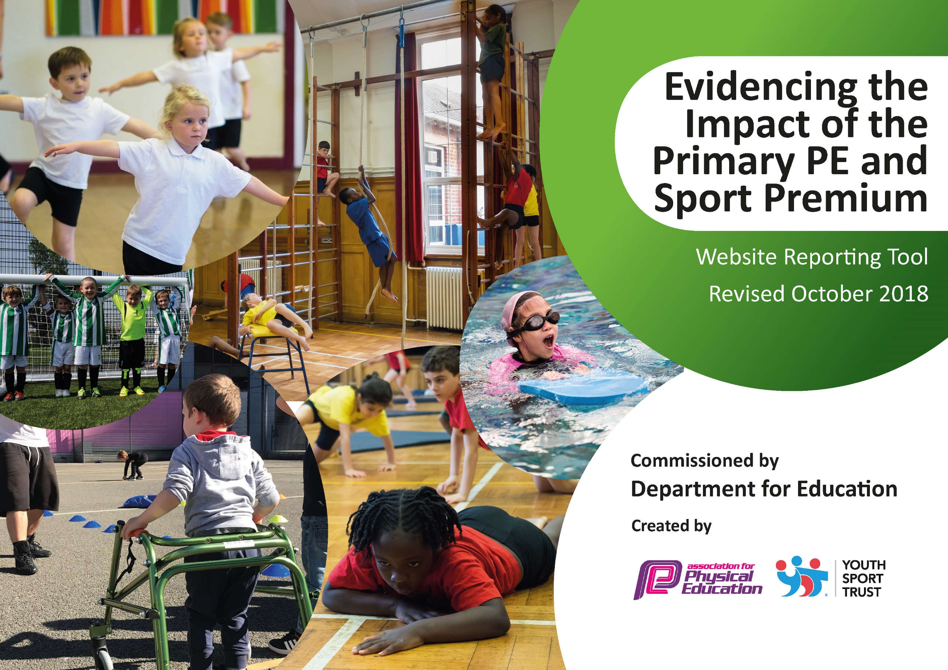
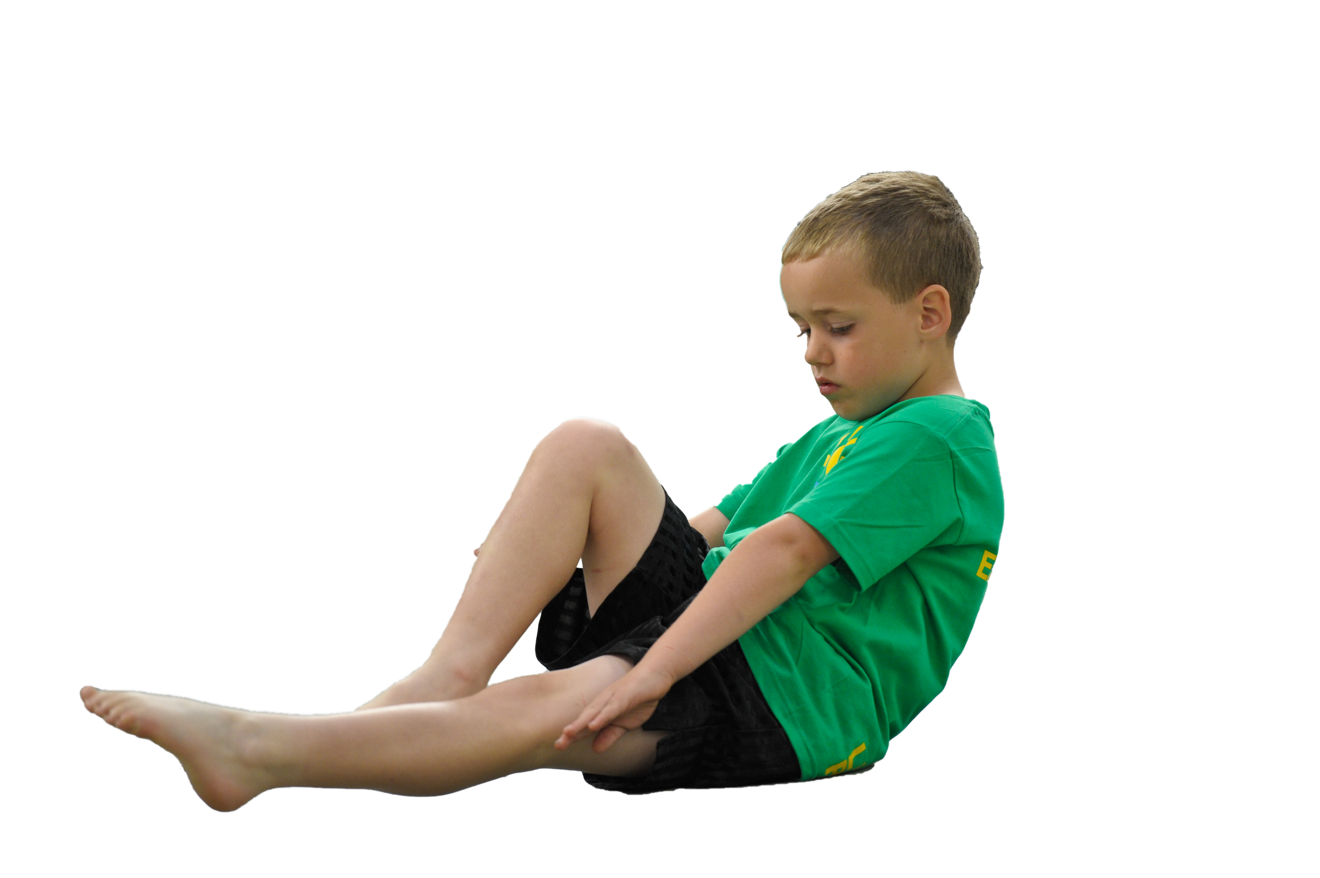
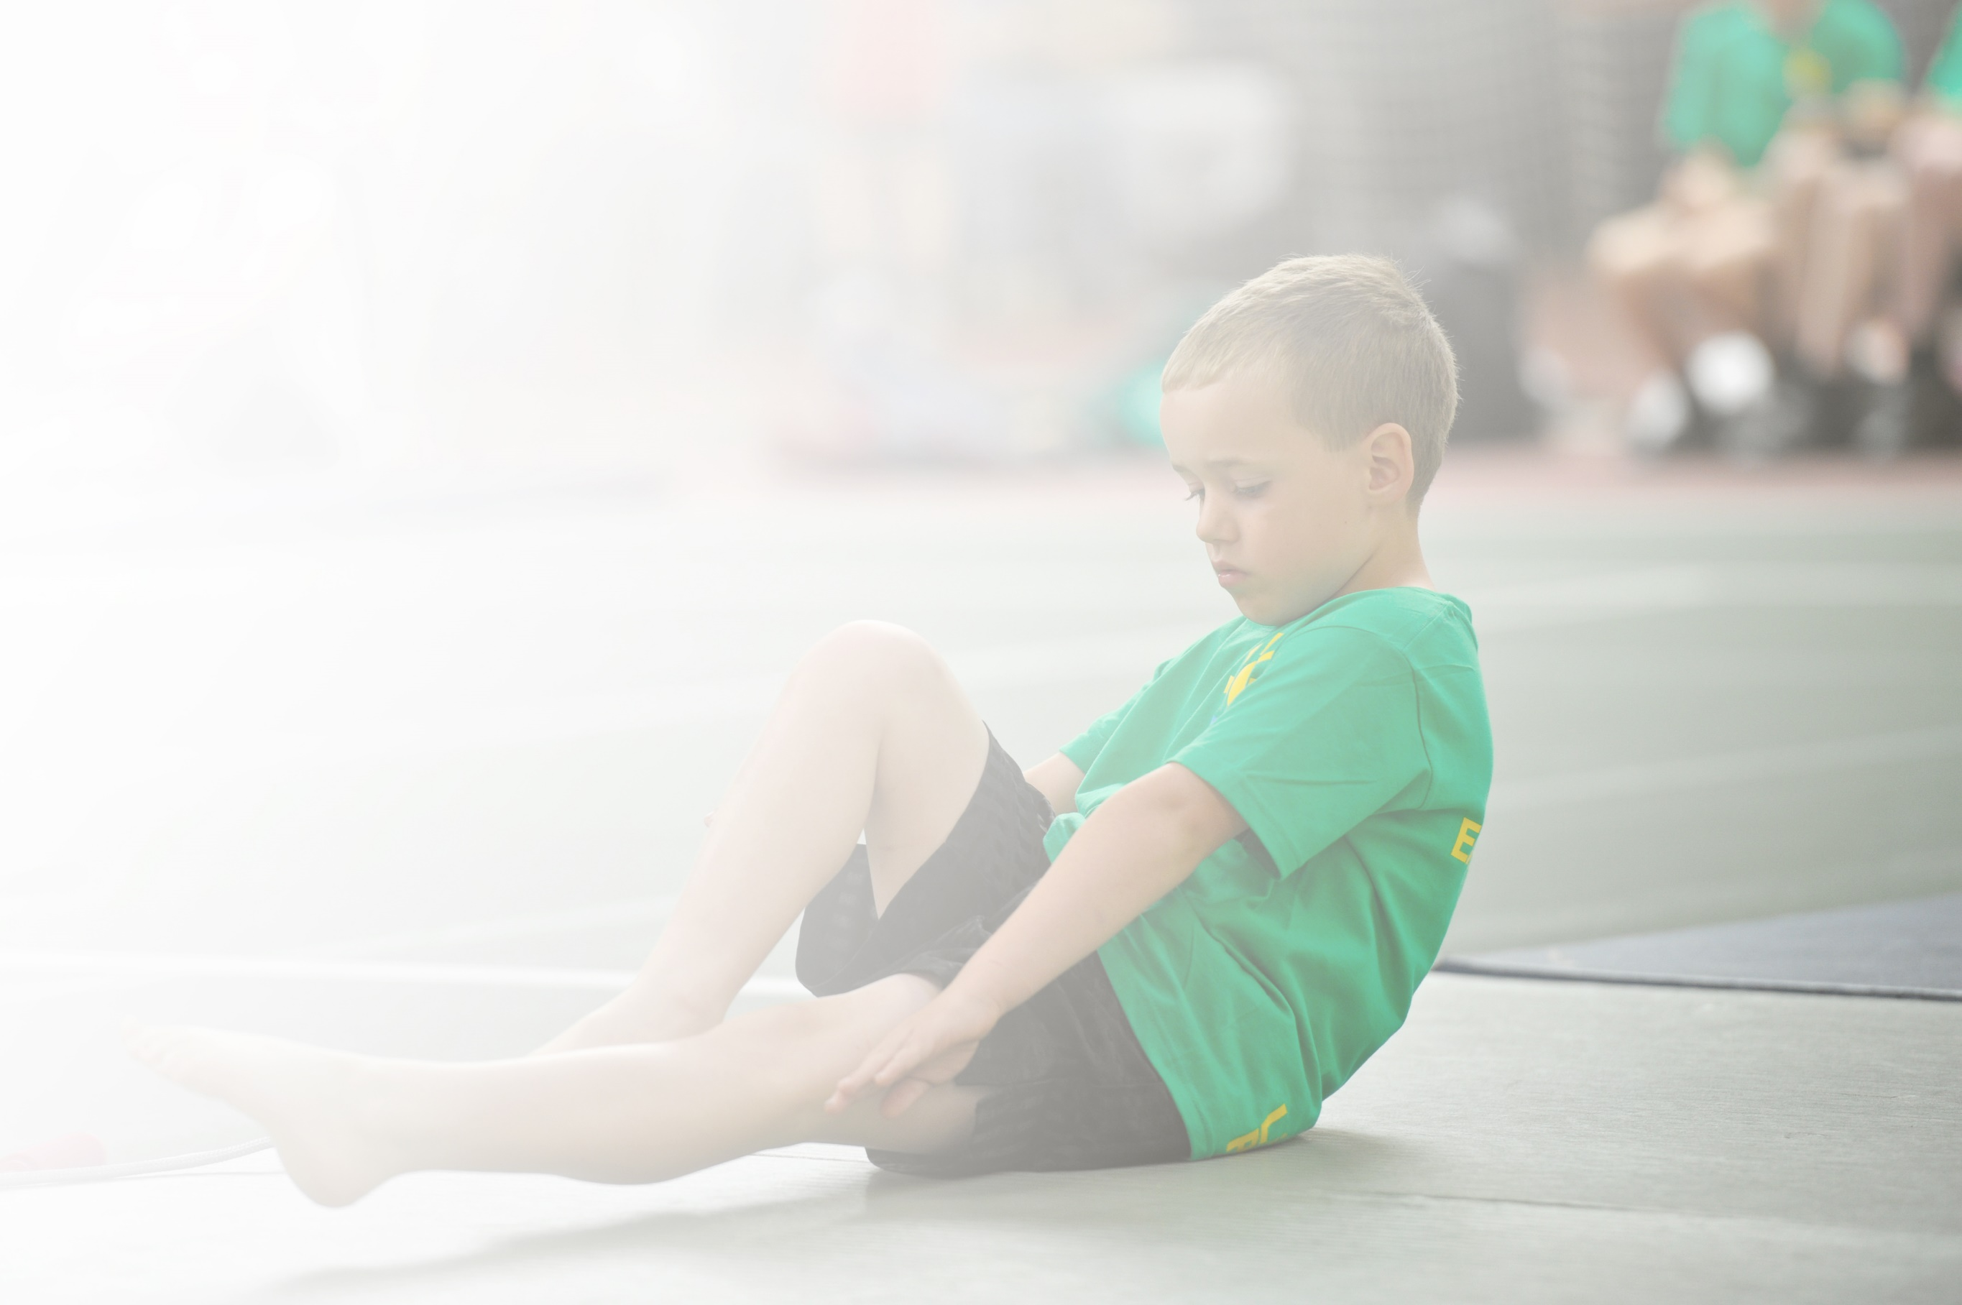
Schools must use the funding to make additional and sustainable improvements to the quality of Physical Education, Sport and Physical Activity (PESPA) they offer. This means that you should use the Primary PE and Sport Premium to:

- Develop or add to the PESPA activities that your school already offer
- Build capacity and capability within the school to ensure that improvements made now will benefit pupils joining the school in future years

Please visit gov.uk for the revised DfE guidance including the 5 key indicators across which schools should demonstrate an improvement. This document will help you to review your provision and to report
your spend. DfE encourages schools to use this template as an effective way of meeting the reporting requirements of the Primary PE and Sport Premium.

We recommend you start by reflecting on the impact of current provision and reviewing the previous
spend. Under the Ofsted Schools Inspection Framework, inspectors will assess how effectively leaders use the Primary PE and Sport Premium and measure its impact on outcomes for pupils, and how effectively governors hold them to account for this.

Schools are required to publish details of how they spend this funding as well as on the impact it has on pupils’ PE and sport participation and attainment by the end of the summer term or by 31 July 2019 at the
latest.
We recommend regularly updating the table and publishing it
on your website throughout the year, as evidence of your
ongoing review into how you are using the money to
secure maximum, sustainable impact. To see an
example of how to complete the table please
click HERE.

Support for review and reflection - considering the 5 key indicators from DfE, what development needs are a priority for your setting and your students now and why? Use the space below to reflect on previous spend, identify current need and priorities for the future.

Key achievements to date: | Areas for further improvement and baseline evidence of need:
Primary School Team of the Year – Basketball  YST Quality Mark for PE – Silver  100% children achieving 2hrs plus PE  Cluster winners – Infant Agility  District finalists Y5/6 Girls Cross Country team  District finalists Y4 Individual Girl Cross Country  District finalists Y5/6 Quad Kids (Athletics)  School Games Award – currently Gold | Development of Active learning across school  Dance  Teaching of Fundamentals in KS1  Purchase a scheme of work to support high quality teaching of Fundamentals across the whole school.  Extra- curricular offer for active lessons (English).

Meeting national curriculum requirements for swimming and water safety | Please complete all of the below:
What percentage of your current Year 6 cohort swim competently, confidently and proficiently over a distance of at least 25 metres?  N.B. Even though your children may swim in another year please report on their attainment on leaving  primary school. | 85%
What percentage of your current Year 6 cohort use a range of strokes effectively [for example, front crawl, backstroke and breaststroke]? | 90%
What percentage of your current Year 6 cohort perform safe self-rescue in different water-based situations? | 100%
Schools can choose to use the Primary PE and Sport Premium to provide additional provision for swimming but this must be for activity over and above the national curriculum requirements. Have you used it in this way? | No

Action Plan and Budget Tracking
Capture your intended annual spend against the 5 key indicators. Clarify the success criteria and evidence of impact that you intend to measure to evaluate for students today and for the future.

Academic Year: 2018/19 | Total fund allocated: £17010 | Date Updated: £17386 June 23rd 2019
Key indicator 1: The engagement of all pupils in regular physical activity – Chief Medical Officer guidelines recommend that primary school children undertake at least 30 minutes of physical activity a day in school |  |  |  | Percentage of total allocation:
 |  |  |  | 40 %
School focus with clarity on intended impact on pupils: | Actions to achieve: | Funding allocated: | Evidence and impact: | Sustainability and suggested next steps:
Daily Mile to become fitter, healthier and more able to concentrate in the classroom.  Active Lunchtime to facilitate all children having positive play experiences and all are physically active.  Maths of the Day to raise attainment and attitudes towards maths.  Active Travel to increase the active travel methods to school. | Every Child to participate in Daily Mile every day  Employ Play Leader  Resources for planned programme  MOTD being a non-negotiable for once a week  BSP Affiliation  Sustrans Active Travel | £0  £3549  £300  £2874  £0 | Tracking of daily, weekly and termly outcomes for each child.  Tracking of participation and engagement.  By outcomes of progression  Tracking of travel methods over a time specific period | Daily Mile continues into next academic year.  Play Leader is going to be funded through school budget.  Look at other initiatives such as Skip to be Fit and introduce.
Key indicator 2: The profile of PESSPA being raised across the school as a tool for whole school improvement |  |  |  | Percentage of total allocation:
 |  |  |  | 18%
School focus with clarity on intended impact on pupils: | Actions to achieve: | Funding allocated: | Evidence and impact: | Sustainability and suggested next steps:
Opportunities and activities offered will be based on pupil voice.  Daily Mile to improve health and fitness and attitudes.  Maths of the Day to improve attainment.  Improve growth mindset.  Breakfast Club ensure children have had access to a healthy breakfast in preparation for learning. | SSOC to undertake pupil survey (Lunchtime provision).  Personal Challenges.  Active Literacy – Primary Playground Programme.  Pay for second adult supervision. | £50  £3000 | Provision is planned based on pupil voice to ensure engagement and participation.  Attitude to learning and attainment rose through physically active and extra-curricular activities.  Children are more confident in trying new skills and engaging adults at home to participate.  Improved physical literacy in target children.  All children’s needs are met. | Use Active English weekly to raise improvement in English.  Continue with Daily Mile.  Continue with Maths of the Day.  Look at other initiatives such as Skip to be Fit and introduce.

Key indicator 3: Increased confidence, knowledge and skills of all staff in teaching PE and sport |  |  |  | Percentage of total allocation:
 |  |  |  | 4 %
School focus with clarity on intended  impact on pupils: | Actions to achieve: | Funding  allocated: | Evidence and impact: | Sustainability and suggested  next steps:
Good-outstanding teaching and learning. Improvement in Fundamental Movement Skills.  Majority of pupils make good progress in PE.  Active lessons and lunchtimes.  More opportunities for Social, Moral, Spiritual and Cultural development. | CPD for all staff  Move with Zip CPD and resources for EYFS staff  Pilot online platform scheme of work  Active lunchtime training (Play Leader)  ROH Dance CPD (KS2 staff) | £65  £500  £50  £50 | Significant increase in fundamentals abilities and ‘whole child’ multi abilities. (based on Y5/6 trail of scheme)  Physical Literacy improving with target groups. | Look at purchasing the full scheme for next academic year based on the impact from pilot/trial.  Continue to provide Physical Literacy interventions as part of an active lunchtime programme.
Key indicator 4: Broader experience of a range of sports and activities offered to all pupils |  |  |  | Percentage of total allocation:
 |  |  |  | 40%
School focus with clarity on intended  impact on pupils: | Actions to achieve: | Funding  allocated: | Evidence and impact: | Sustainability and suggested  next steps:
To develop a broad range of sports and PE activities across the school and its curriculum.  EYFS children have access to appropriate equipment to support Physical Development.  Skills and children’s abilities are improved and experiences are increased using the variety across the curriculum.  Opportunities and activities offered will be based on pupil voice.  Continue to offer a wide range of activities within and outside the curriculum in order to get more pupils involved, especially disengaged and target groups. | Purchase new equipment:  Archery set  Dodgeball set  Hockey set  Early Years PD equipment  Complete pupil survey as to what pupils would like (PE, Playtime and Lunchtime)  Pleasley Vale I can do it  Pay for second adult to accompany to Pleasley Vale  Indoor Bowling Coaching  After School Clubs:  - Samba Sport  - RuggerEds (x4 terms)  - Chesterfield Football Club (x2 terms)  - Dance Dayz (cfc – 1 term)  Bikeability for Y6 ( funded places through affiliation) | £1124  £130  £2640  £134  £0  - £315  - £1485  - £540  - £280  £0 | All children have access to quality and sufficient equipment to support their success in PE, extra-curricular activities and active lessons.  All Y5 improved their growth mindset. Cognitive skills, social skills, personal achievements and developed skills through activities which cannot be provided in school.  All children developed skills to be able to compete in intra-school and inter-school competition. | Continue to replace and/or provide necessary resources to support the delivery of HQPE to all.  Continue to offer and encourage CPD for staff so that the provision of extra-curricular activities can become self-sustaining.  Continue to offer access to Outdoor and Adventurous experiences which complement and enhance the NC.
Key indicator 5: Increased participation in competitive sport |  |  |  | Percentage of total allocation:
 |  |  |  | 2 %
School focus with clarity on intended  impact on pupils: | Actions to achieve: | Funding  allocated: | Evidence and impact: | Sustainability and suggested  next steps:
Transport to sporting events.  Maintain participation levels in competitions and events. | Quotes for transport from several providers and book the most appropriate.  Regular Cluster meetings to have a voice on the competition calendar. | £300 | Children were able to access sporting competitions and festivals located off site.  Termly Subject Lead Cluster meetings to collaborate on the BSSP offer and curriculum. | Look at sharing transport with other schools going to same venues to keep costs down and transport ourselves where possible.  Continue to attend Subject Lead Cluster meetings,

- The overspend of £376 has been offset by the reimbursement from Sport Club charges of £489.90 leaving a carry forward of £113.90

